♂18. Chariot (Rockets of Desire or Heart’s Desires)—Track 22 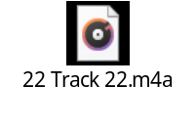

The camera that was to capture the hearts and minds of people was a Kodak box camera known as the Brownie. Most likely a nickname in honor of its creator, Frank Brownell, the first Brownie was sold in 1900. The last Brownie, an updated version of the original, was still on the market almost eighty years later.
One of the big reasons the Brownie caught on so quickly was the price. It only cost one dollar. At fifteen cents a roll, the film was no less of a bargain. “Photography,” noted Eastman, “is thus brought within reach of every human being who desires to preserve a record of what he sees.”
